Maher, Terry (largely based on Linked In web data)
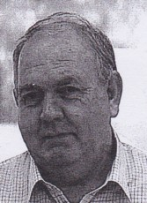

Graduated from Dwellingup Cadet School in 1967. Worked For Forests Department, CALM , DEC. In late 1960s, early 1970s worked in Pemberton, Walpole and Nannup (1973-). With Manjimup Working Plans Office in 1970.
Senior Forester at Albany in 1988. Principal Fire Operations Officer in 2000s at Como. International bush fire and forestry experience. Managing Director of Deontic Consultants Pty Ltd an international Company.

